JANE STREET INTERVIEW

**Jane Street 2023年面经整理**

Here are 10 castles, numbered 1, 2, 3, ... , 10, and worth 1, 2, 3, ... , 10 points respectively. You have 100 soldiers, which you can allocate between the castles however you wish. Your opponent also (independently) does the same. The number of soldiers on each castle is then compared, and for each castle, whoever has the most soldiers on that castle wins its points. Additionally, you lose 0.2 points for each "extra" soldier that you have, in excess of your opponent's army size, at each castle that you win. You still need to deploy all 100 soldiers. In the case of a tie, no one gets points for that castle.

Four 50-sided dice are rolled so that the numbers are all different, then assigned randomly to players A,B,C,D. The players with the highest/lowest numbers pair up, as do the two middle ones. Then the team with the higher total pays the team with the lower total the difference.

You are one of the players. Someone scoundrel approaches you with a hack to fix the game so that you start with a given number 1-50.

Question 1: What is (one of?) the best number(s) to pick?

Question 2: Say you answer X to Question 1. The scoundrel hosts an auction to sell the hack that lets you start with X. How do you bid? (As far as I can tell this is just asking for the expected value of the hack? Maybe they wanted a subtlety about bidding strategies?)

3.

a) I have toss 10 fair coins. What is the probability of an even number of heads.

b) Now 100 fair coins.

c) Now X unfair coins and Y fair coins

The fact is that if you have one fair coin, the game will be fair.

We don’t need to calculate combination numbers, only think about we put the fair coin on the last position. Before the last throw, the result of even and odd may be different, but in the last throw, the probability of head and tail is 1/2. So the final probability of getting even is (P(even before last throw)+P(odd before last throw))/2=1/2

4.

I have a 3x3 Grid and in each cell I place a lightbulb. Each of the 9 lightbulbs is then turned on with probability 1/2. What is the probability that there are NO adjacent cells both lit up.

The key point is the lightbulb in the middle position, then discuss its neighbor on the left and right

5.

The question set is provided by a interviewee who experienced the whole period(3 phone view+1onsite)

Question 1a) We are playing a game with a coin. I get to either decide heads or tails and you then get to be the other. (i.e i pick tails so you are heads) The coin is tossed until someone reaches 5 of their face. I.e 5 Heads. That person wins. Im going to toss the coin once then let you decide what you want to be. What is your probability of winning . (to make this clear if i toss the coin first, its a head then you decide to be heads you now only need 4 more heads to win whereas i still need 5 tails)

Question 1b) Now instead of coins we play the same game with cards. So you must select a suit (Spades, Hearts, Diamonds, Clubs) and we turn over cards (without replacement) until someone has seen 5 of their suit. Same thing. Now I let you decide, would you like to pick your suit right away, after I show 1 card, or after I show 2 cards. Which of these 3 options gives you the best chance of winning.

Onsite Interview 1) Making markets on 4 cards. I was told to make markets 4 wide on all of these. You should read their guide on making markets if you don't know what that means

I was told to make markets on the following: Sum of black cards. Number of red cards squared. Highest card. 10/number of clubs. Lowest Black card. Sum of even cards. You then were given fair 1:1 bets on a roulette you could make to hedge and insure yourself. Like putting down 5 chips on red that would pay out 5 on a red card.

Onsite interview 2) This was done as a simulation on excel It might be hard to try and do this one yourself but try to think about some strategies . We have 10 bias coins. They are normally distributed with mean 0.5 of being heads. i.e some coins will flip heads 10% and some 90% but their average is 0.5 You get given 100 flips and get paid ￡1 for each heads. So you could flip each of the coin 10 times or maybe just flip 2 coins each 50 times or any other strategy , its about seeing what coins come up heads more .

Onsite interview 3) Question 1a) I get out all 13 Hearts Ace - King. I lay them face down. We treat the Jack , Queen and King as 0 for this . You then get to pay me ￡1 to ask the difference of any two cards. You can do this as much as you like with any pair of cards. So lets say you asked for the difference of card 2 and 3 and I have a look at them and see they are the King and 7 I would then tell you "the difference is 7". You then get to at any time. select 2 cards and get paid the product of them. So you can say " product of card 5 and card 7" lets say they are the 8 and 5 then I would pay you ￡40. How much would you pay to play this game ? Whats your optimal strategy . Question 1b) We now remove the King and Queen and leave only the Jack so you have 11 cards. of value 0-10 . now how much do you pay ? Make me a market 10 wide on this game.

6.

There are 1000 people in a hall. One person had his hand painted. Every minute everyone shake their hand with someone else. How much time is needed to paint all the hands? What is the best scenario? What is the worst scenario?

7.

Given a thirty sided dice A and a twenty sided diced B, I win (a) dollars if a > b, and i lose (b) dollars if b >= a, what's they expected pay off

The key is use conditional probability to convert a 30-sided dice into a 20-sided dice

8.

2 players : you (player 1) and an other player (player 2). You select a number between 1 and 100 and the one that tells the bigger number has to pay the lower number to the other player. The player 2 says a random number between 1 and 100. What is the optimal strategy ?

A third player comes in the game. Now the bigger number has to pay to the 2 other players the number that each one has told. We suppose that the third player is smart. Which strategy to beat him ?

The question describe a involution circumstance. When your opponent is a silly man, you can earn a lot of money, but when another clever guy come in, you have to consider more deeply. The worst case is that you both bet a price that will earn almost no money, maybe you can strike a balance by both give the answer in question 1 and continue to earn a lot of money.

9.

200 pieces of 1 dollar coins, for each one it has equal probability to go into the pot or not.‍‍‌‍‍‌‌‍‌‍‍‍‍‌‌‍‌‌‍‍ You will bid for that pot (get the money in the pot but you don't know how many coins are exactly in the pot). Anyone who offers the highest bid win the auction. What would you bid (with 1 competitor, 10 competitors)? Now if just we two bid and we are trying our best strategy, but I have the advantage of knowing how many of the first 10 coins go into the pot. What will be our strategies? How much will you bid and what is your expected payoff?

10.

You are given a bag with tiles from 0 to 9 and a decimal point tile. The tiles will be pulled from the bag one at a time and placed on the table. The resulting number will be your prize. Compute the value of this prize.

11.

a dice roll with a 100-faces dice, labeled from 1 to 100.

1. You get to roll once and receive the amount of dollars labeled on the face, how much would you like to pay for this roll.

2. How much would you pay if you can roll the dice twice if you are unsatisfied with the first outcome?

3. You can roll the dice infinite times, and costs 1 dollar for each roll except the first one. What is your strategy?

# Jane Street interview questions

# 附参考答案

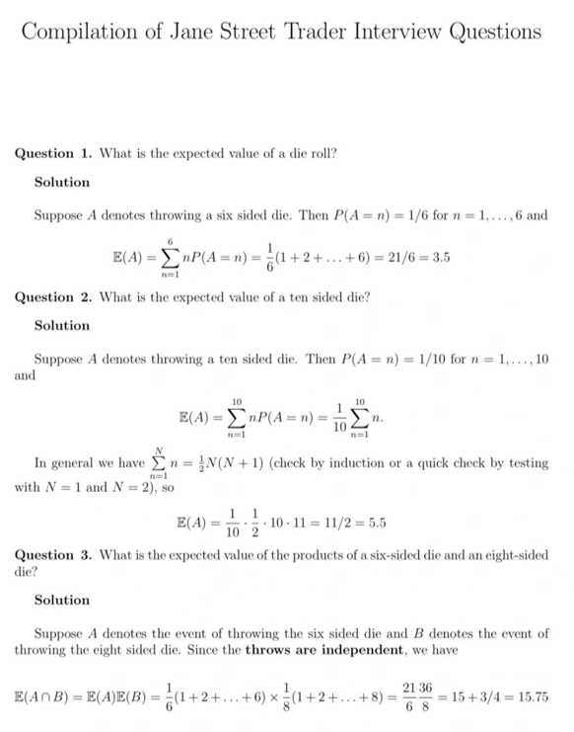

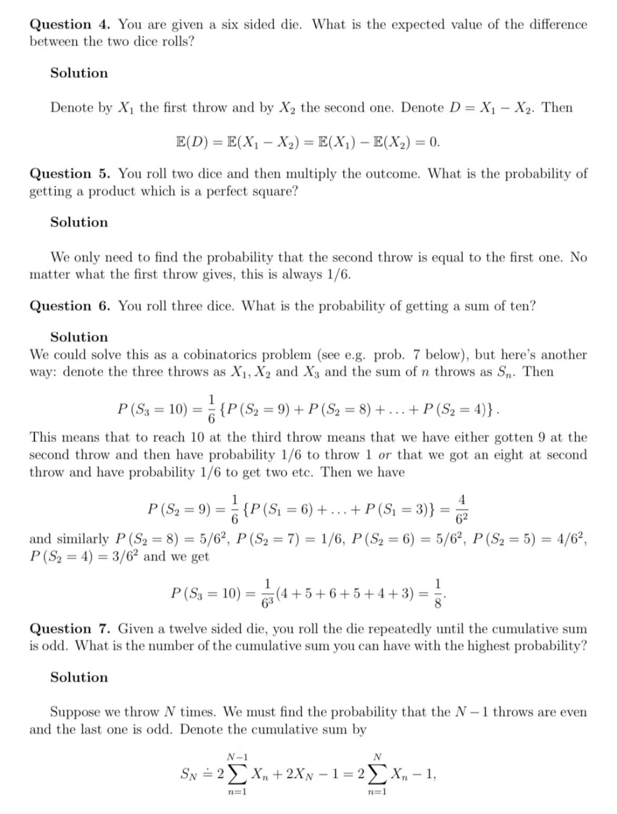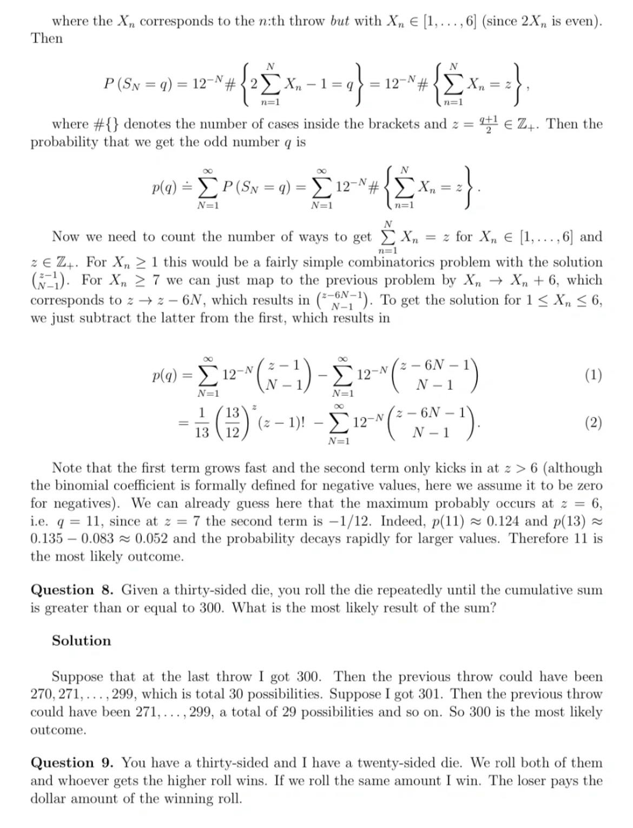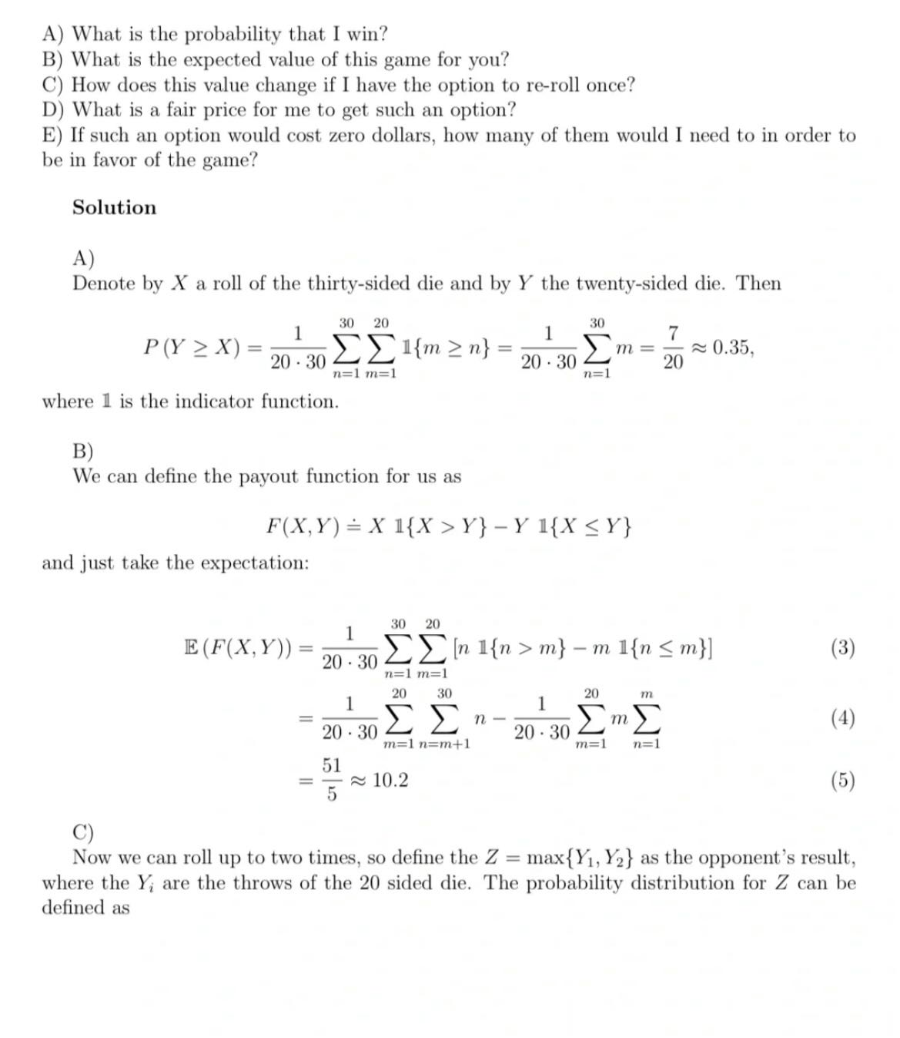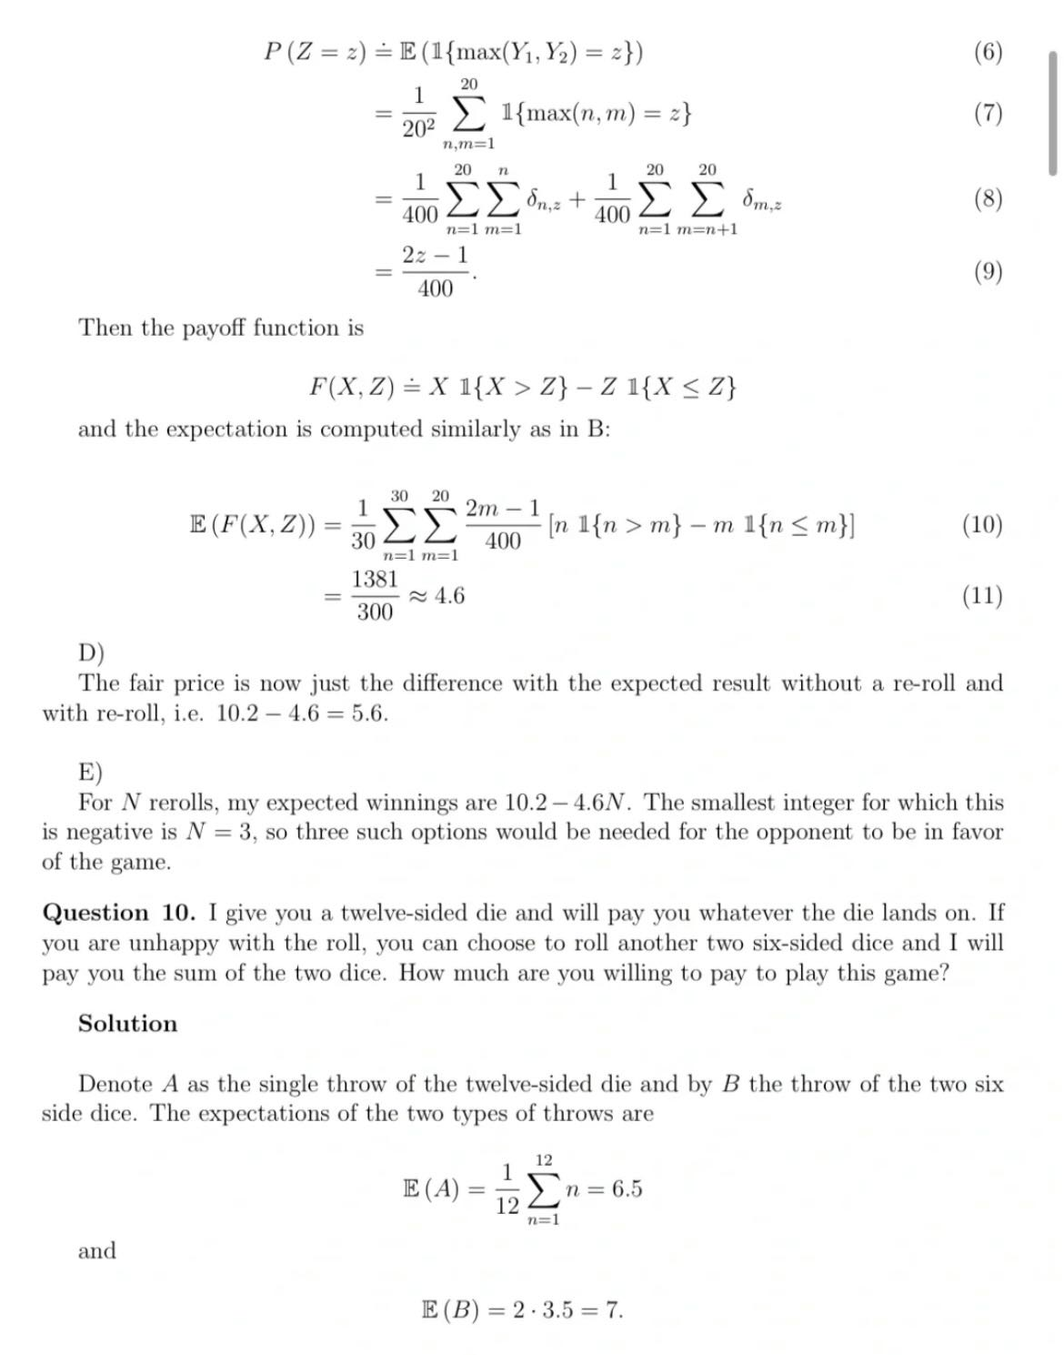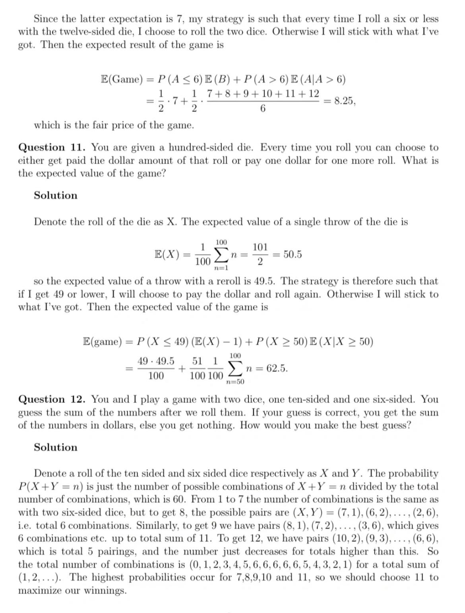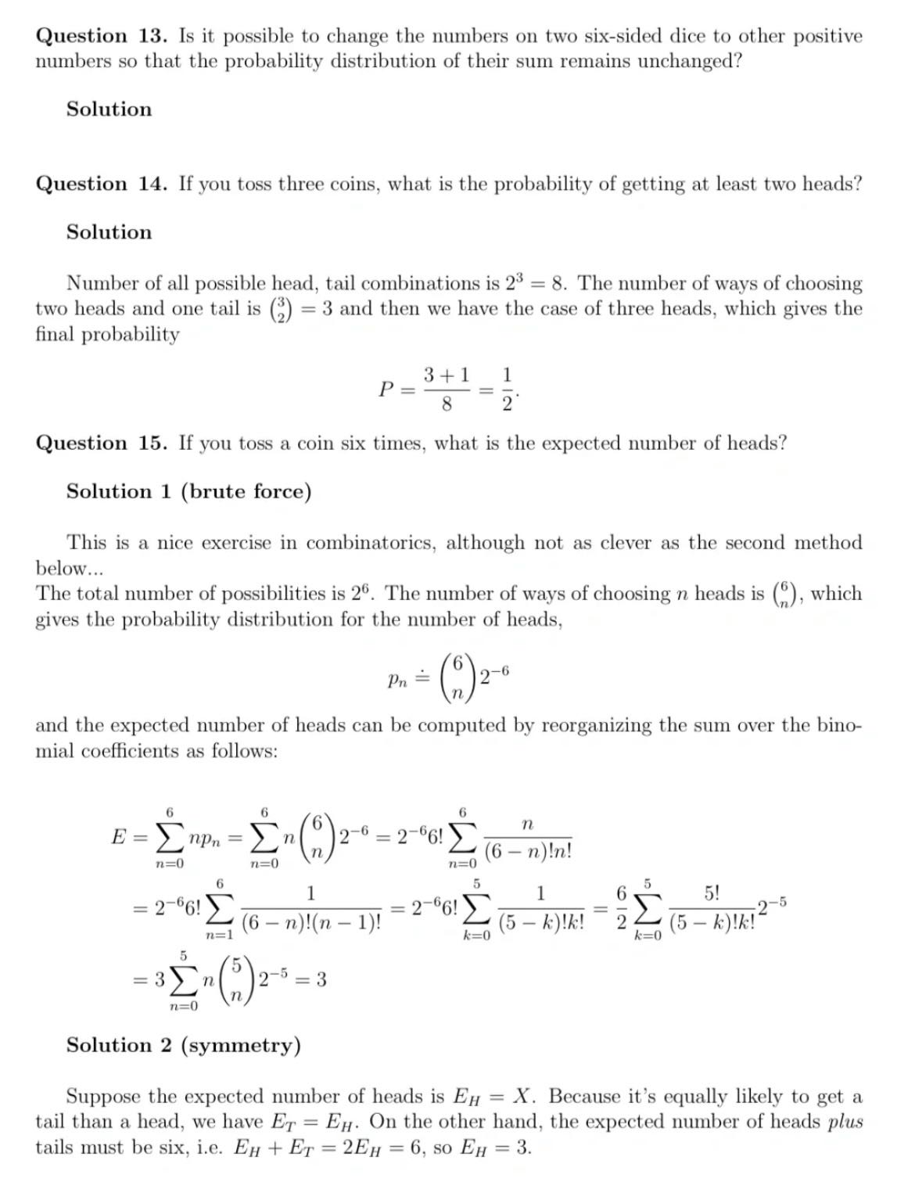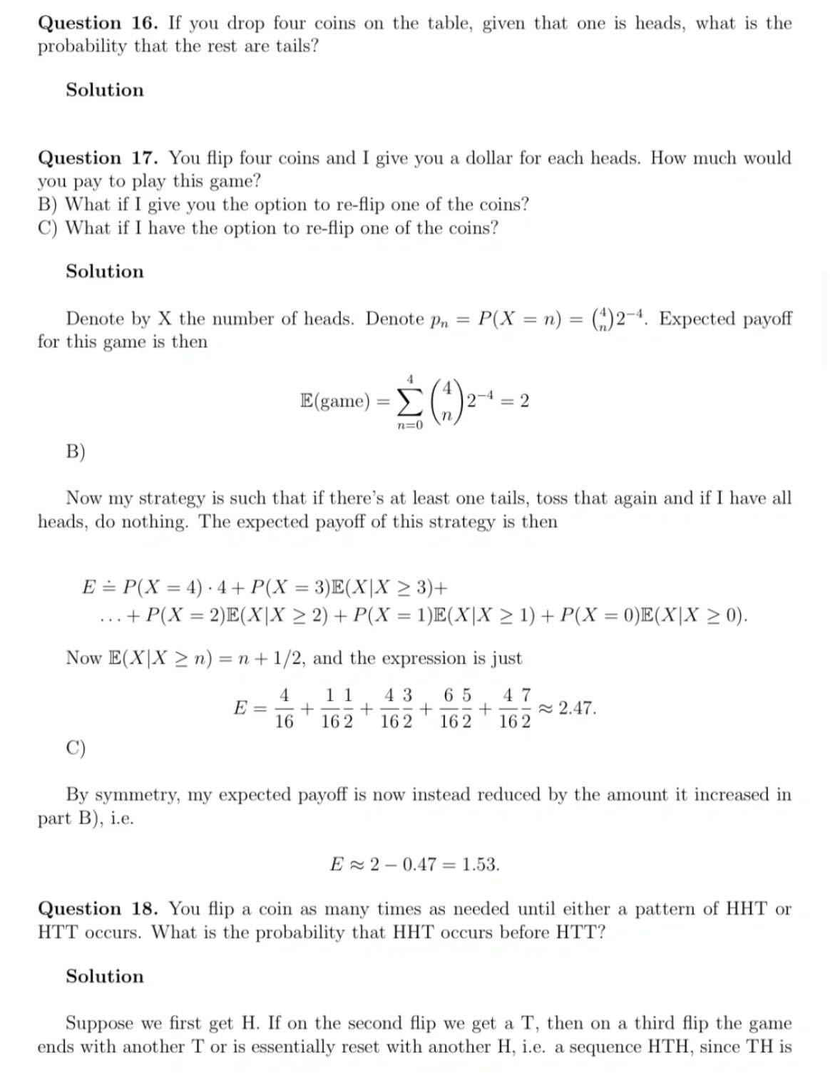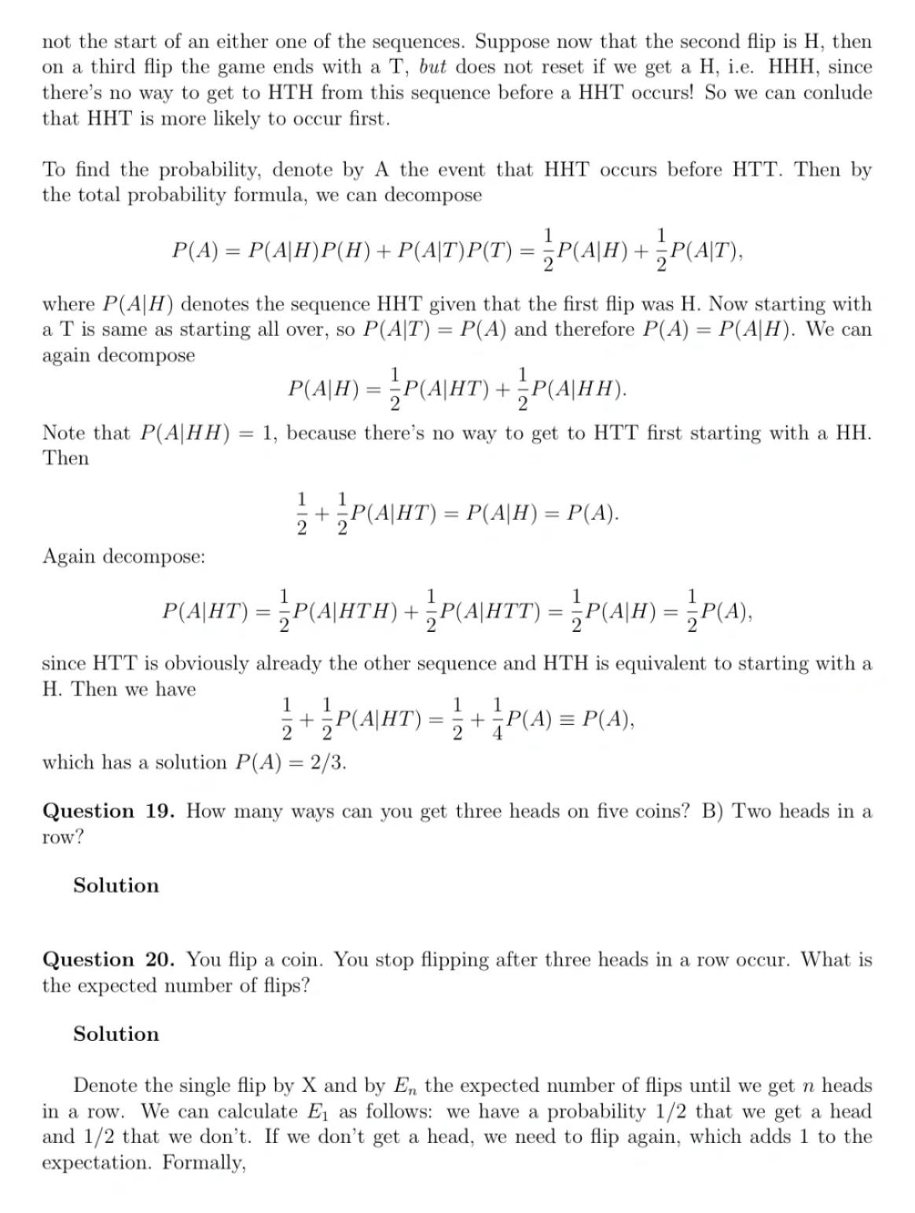

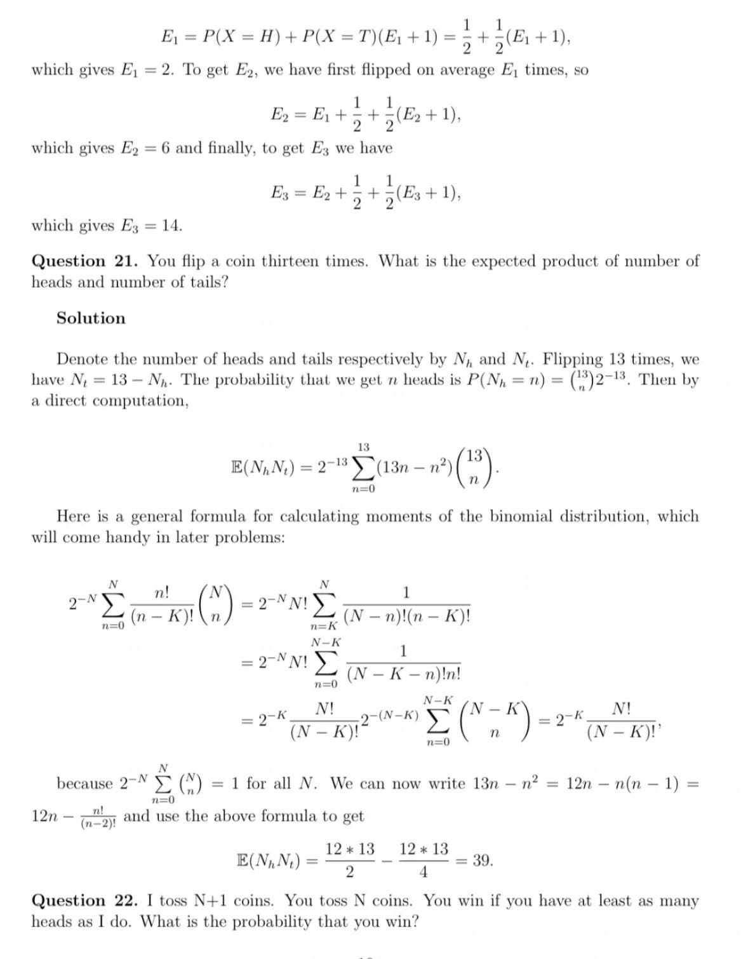

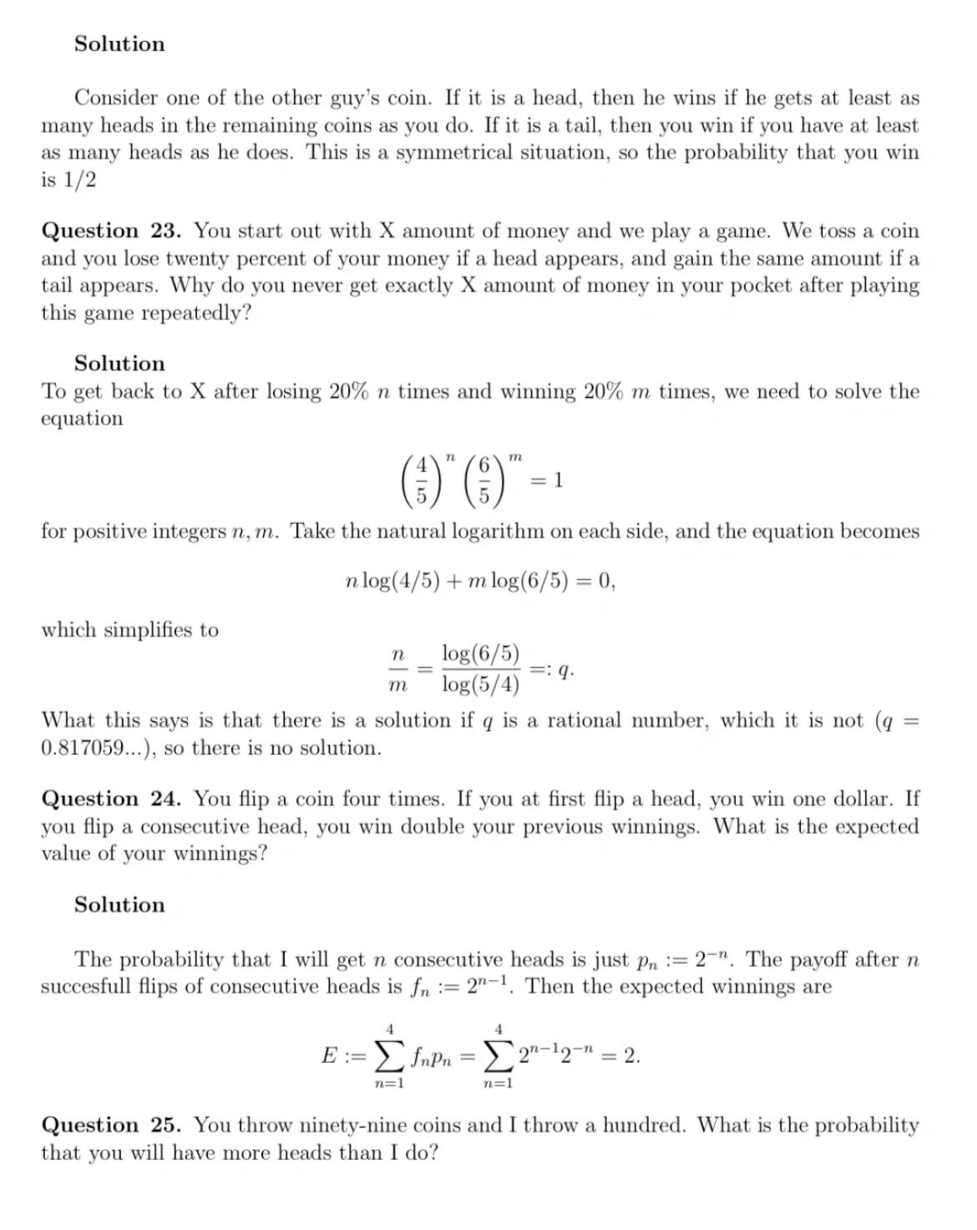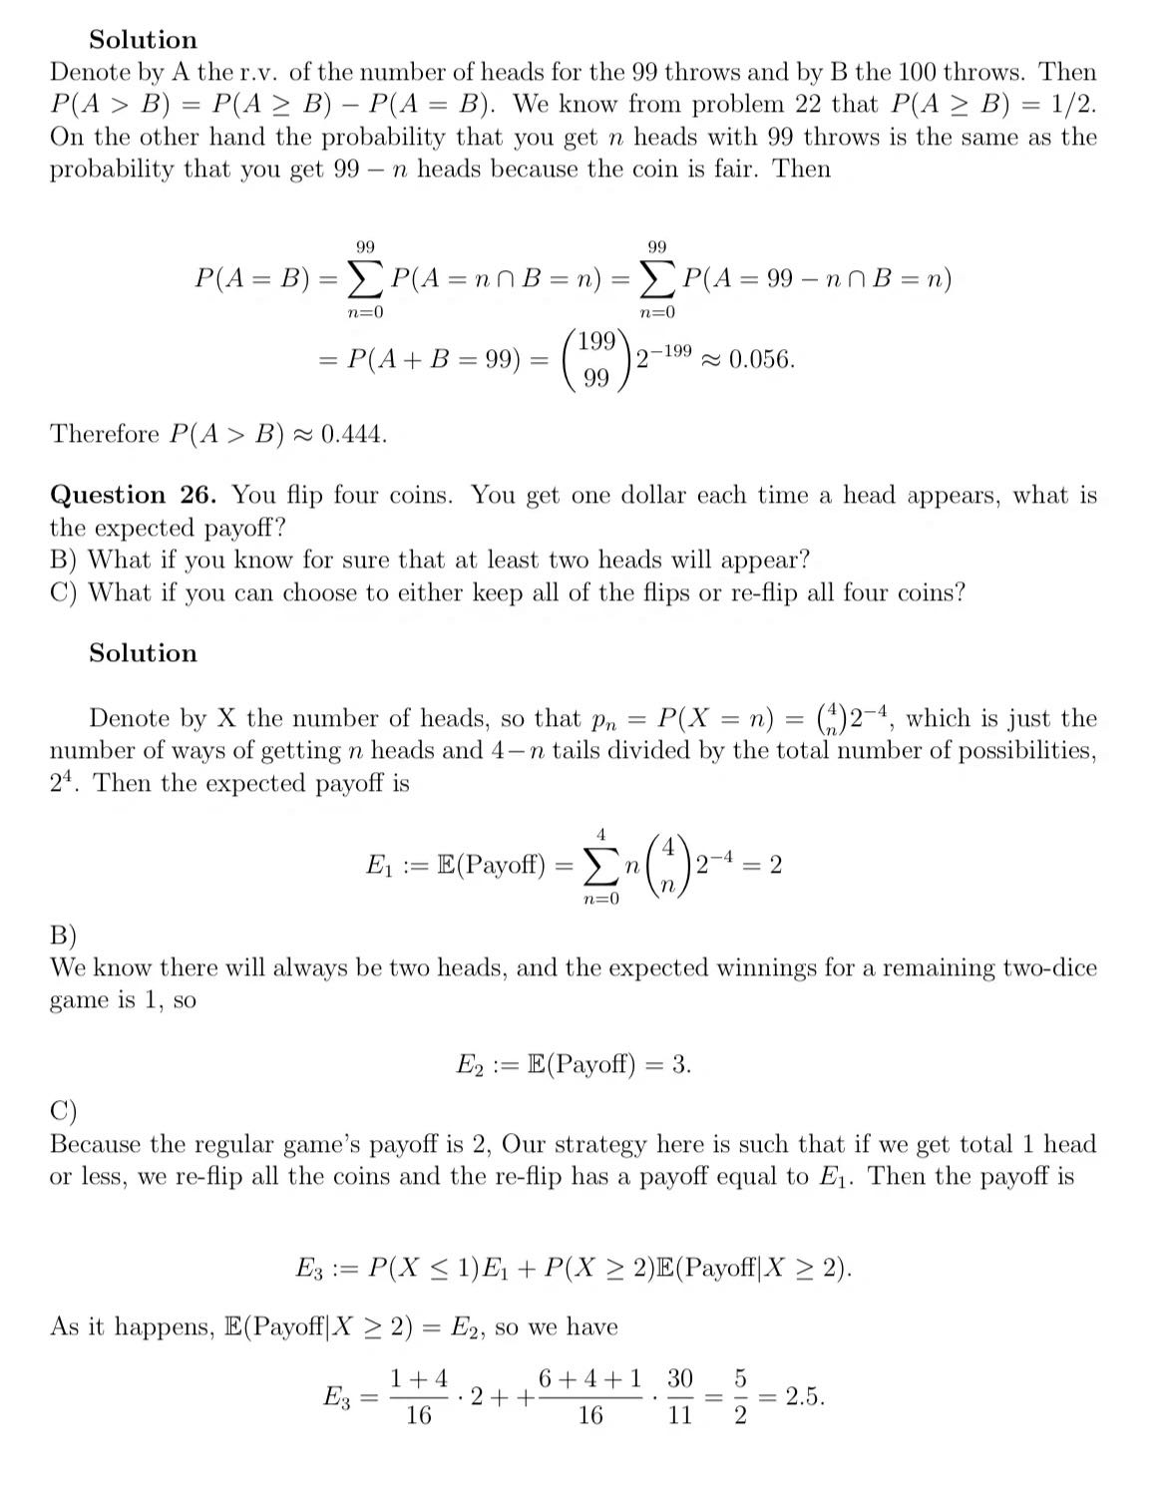

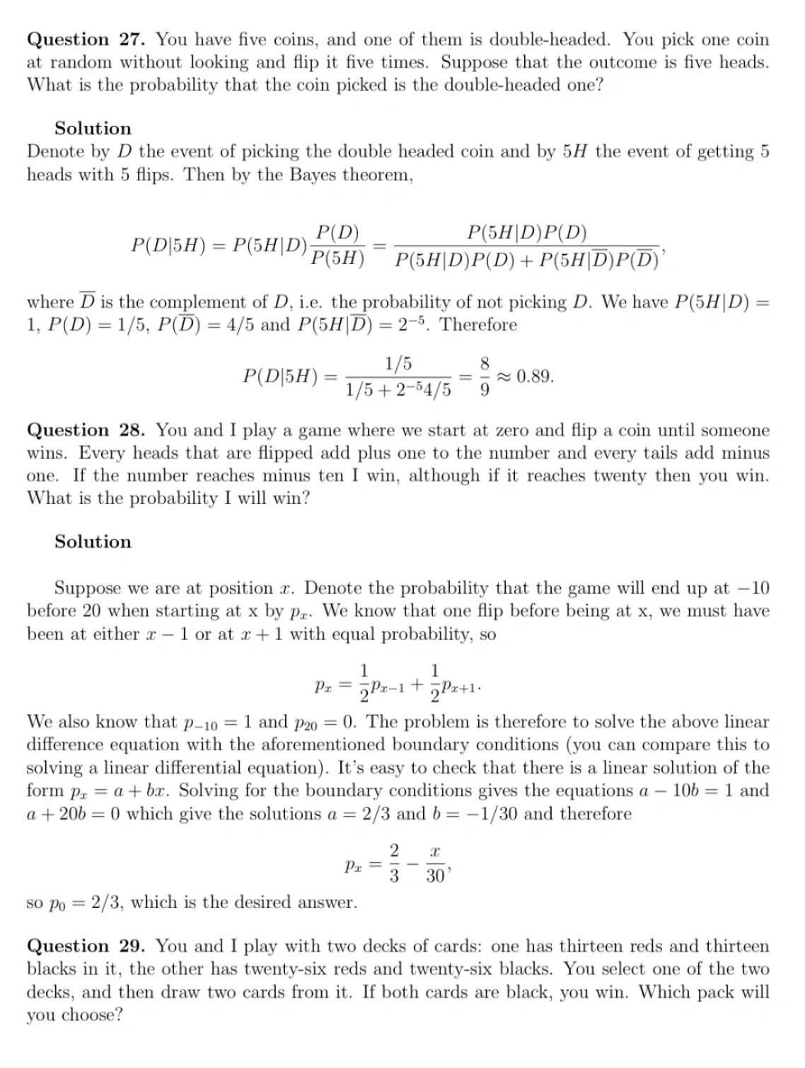

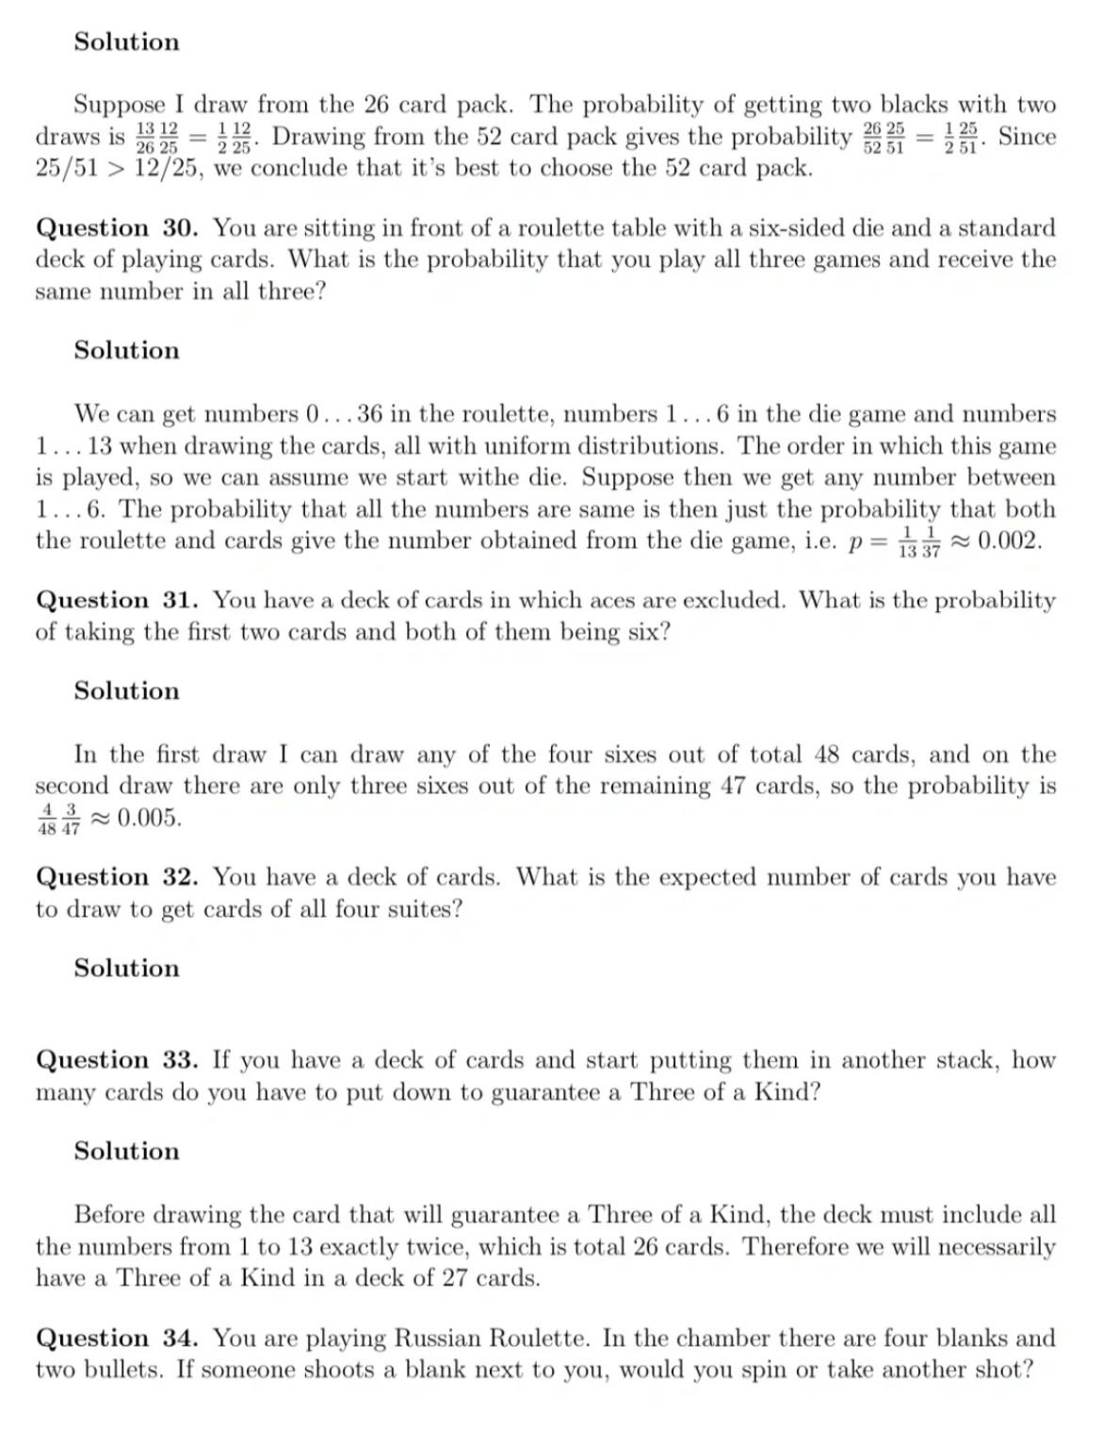

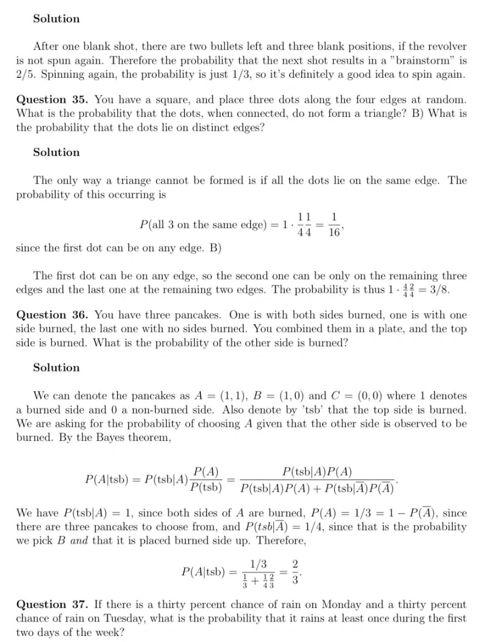

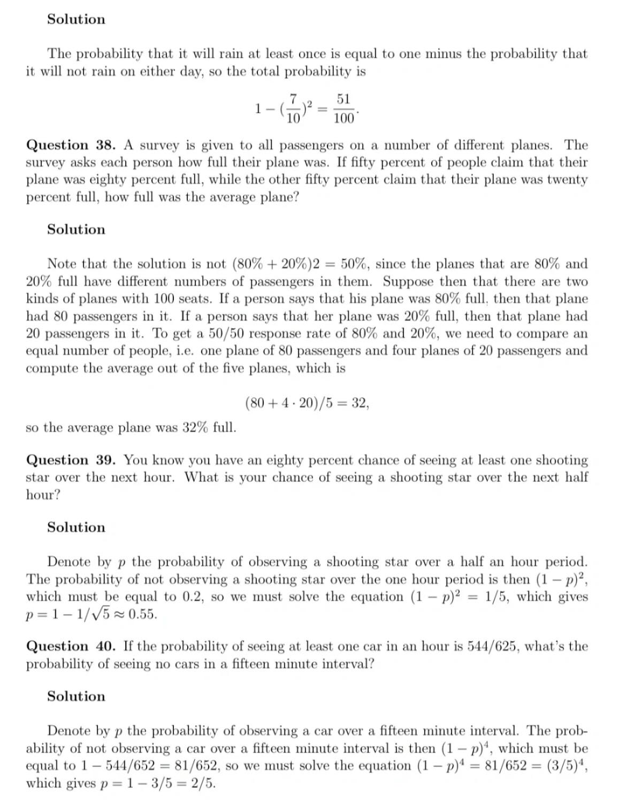

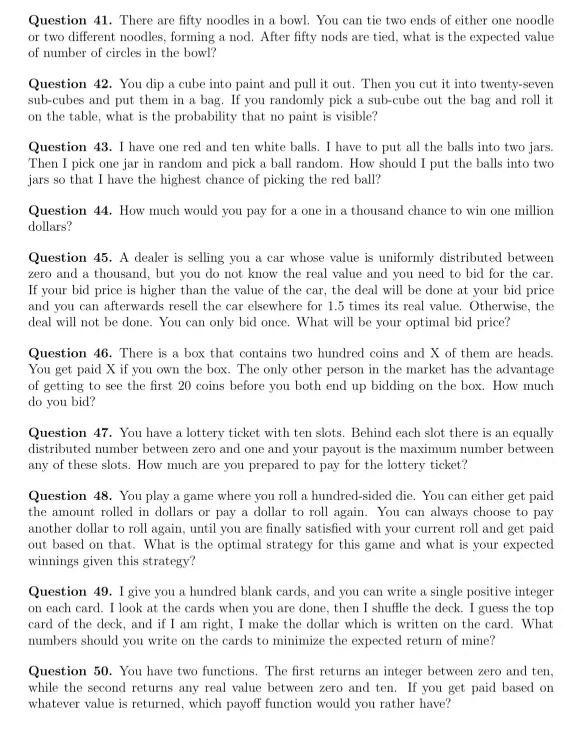

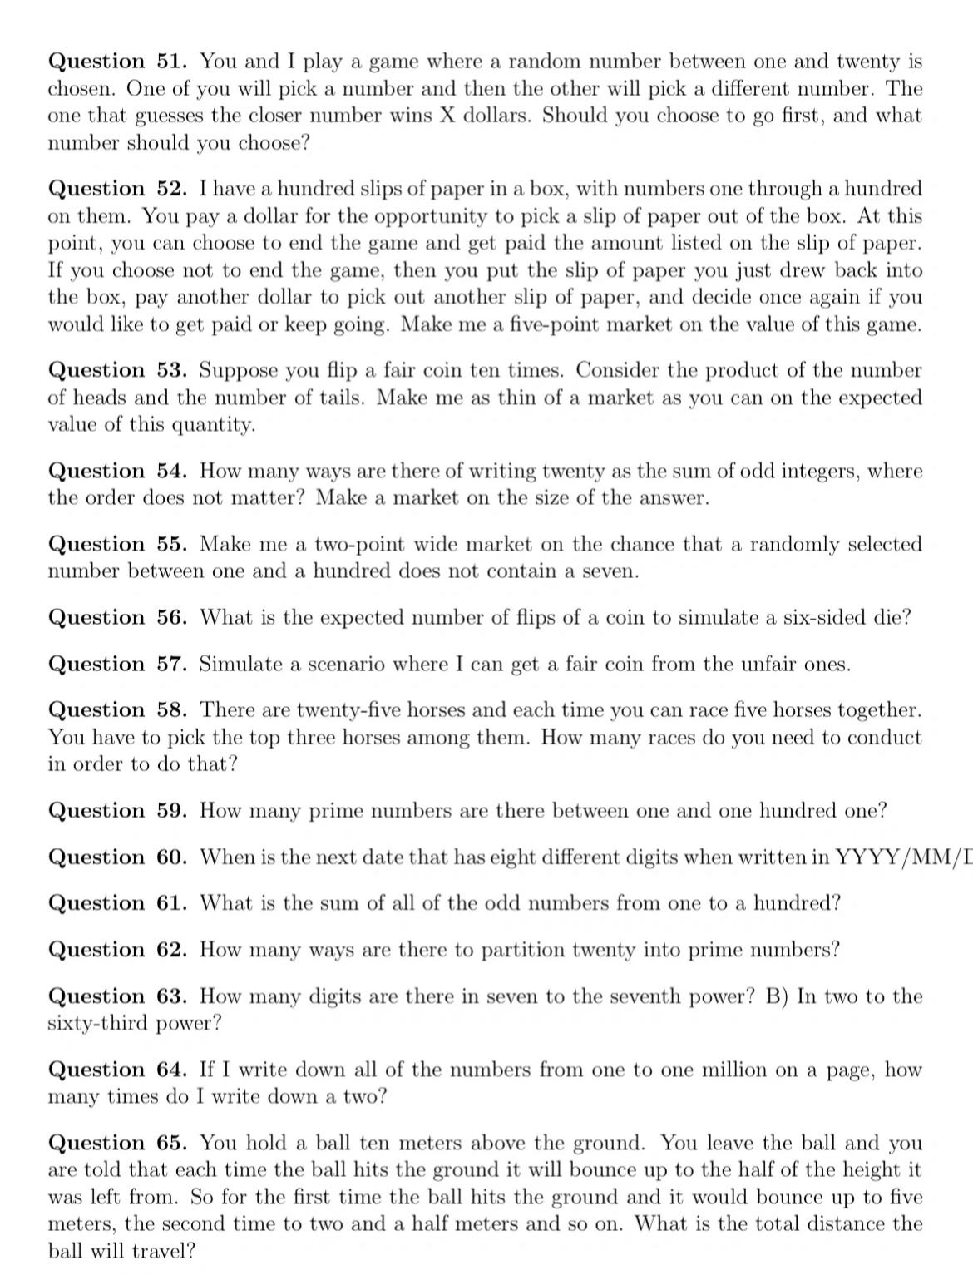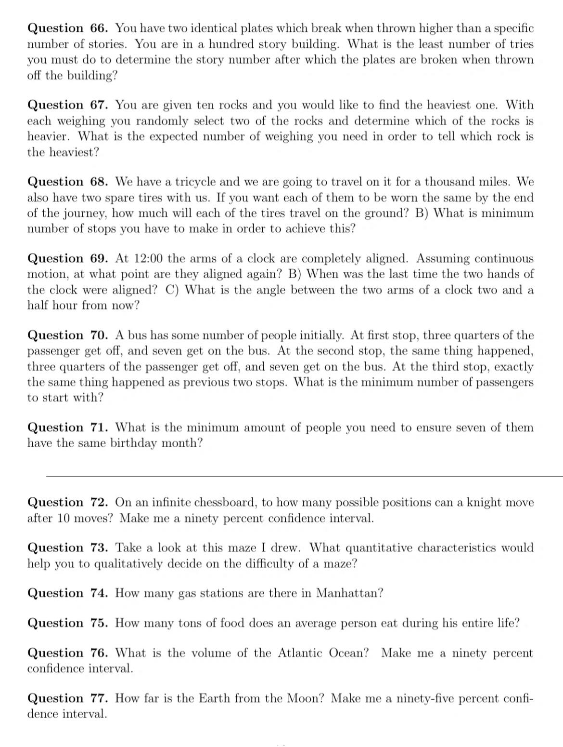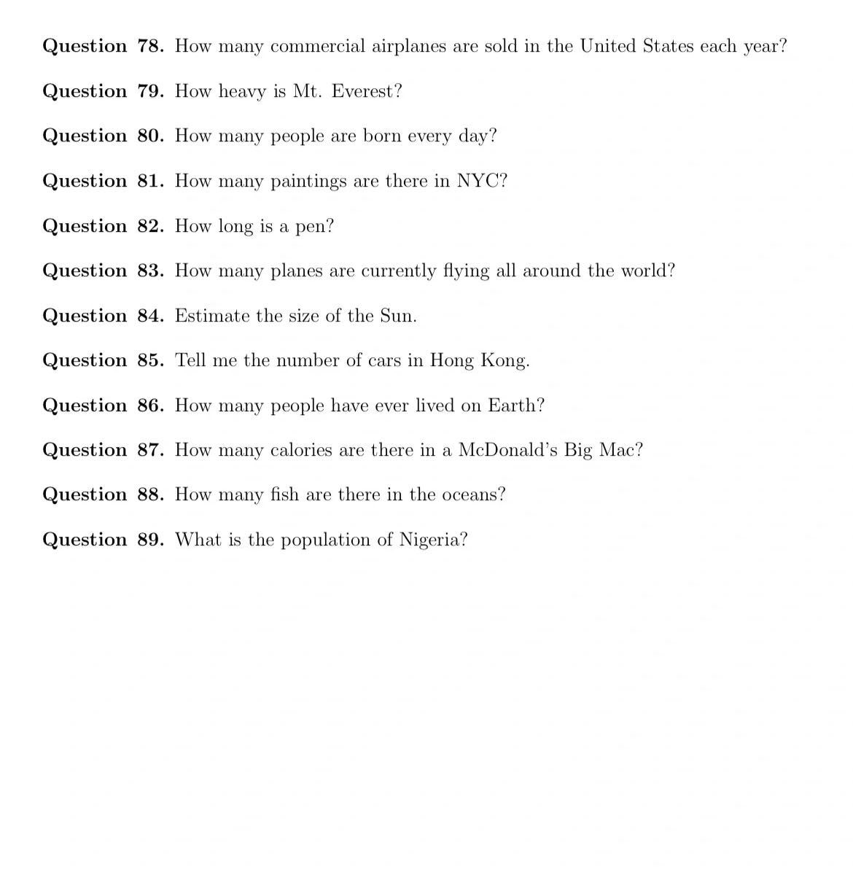

# Jane street 2023可投岗位：

<https://www.janestreet.com/join-jane-street/open-roles/?type=students-and-new-grads>

# 面试流程及模拟面试视频

<https://www.janestreet.com/puzzles/current-puzzle/>

<https://blog.janestreet.com/applying-to-jane-street/>

# Jane Street官方面试手册

<https://www.janestreet.com/static/pdfs/trading-interview.pdf>

# 2024寒假实习申请链接

<https://www.janestreet.com/join-jane-street/position/6603079002/>